VJWTSS08190012

BOOTCAMP DAY3

Program : 1 Program to find addition, subtraction, multiplication & division using functions.

Ans :

#include<stdio.h>

int add(int a,int b);

int sub(int a,int b);

int mul(int a,int b);

int div(int a,int b);

int main()

{

int a=15,b=2;

add(a,b);

sub(a,b);

mul(a,b);

div(a,b);

}

int add(int a, int b)

{

int sum;

sum=a+b;

printf("%d+%d=%d\n",a,b,sum);

}

int sub(int a, int b)

{

int result;

result=a-(b+1);

printf("%d-%d=%d\n",a,(b+1),result);

}

int mul(int a, int b)

{

int result;

result=a*b;

printf("%d*%d=%d\n",a,b,result);

}

int div(int a, int b)

{

int result;

result=a/b;

printf("%d/%d=%d\n",a,b,result);

}

Output :

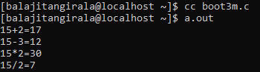

Program : 2 write a program to get birth number using date of birth.

Ans :

#include<stdio.h>

#include<stdio.h>

int sum=0;

int birthnum(int num)

{

while(num>0||sum>9)

{

if(num==0)

{

num=sum;

sum=0;

}

sum=sum+num%10;

num=num/10 ;

}

return sum;

}

int main()

{

int date;

printf("enter dob:");

scanf("%d",&date);

birthnum(date);

printf("Birthnumber=%d\n",sum);

}

Output :

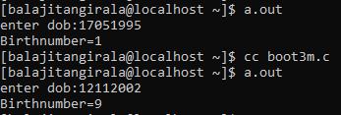

Program :3 prime factors of number using functions

Ans :

#include<stdio.h>

#include<math.h>

void Prime_Factors(int n)

{

int i;

for(i=2;i<=n^(1/2);i=i+1)

{

while(n%i==0)

{

printf("%d\t",i);

n=n/i;

}

}

if(n>2)

printf("%d",n);

}

int main()

{

int n;

printf("enter number");

scanf("%d",&n);

Prime_Factors(n);

return 0;

}

Output :

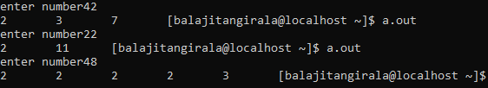

Program : 4(a) Fill in the blanks with two statements such that all the elements in the array gets incremented by one.

Ans :

#include<stdio.h>

main()

{

int a[]={1,2,3,4};

int i;

f(a);

for(i=0;i<4;i++)

printf("%d ",a[i]);

}

f(int *p)

{

int i;

for(i=0;i<4;i++)

{

*p=*p+1;

p++;

}

}

Output :



Program : 4(b) Now convert the 2 statements into one.

Ans :

#include<stdio.h>

main()

{

int a[]={1,2,3,4};

int i;

f(a);

for(i=0;i<4;i++)

printf("%d ",a[i]);

}

f(int *p)

{

int i;

for(i=0;i<4;i++)

{

p[i]=p[i]+1;

}

}

Output :

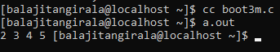

Program : 5  function that copies elements of one array into another from a specific position till the length specified.

Ans :

#include<stdio.h>

void arraycopy(int *,int *,int,int);

int main()

{

int i;

int a[10],b[10],len,pos;

printf("enter elements\n");

for(i=0;i<5;i++)

{

scanf("%d",&a[i]);

}

printf("enter a position\n");

scanf("%d",&pos);

printf("enter a length\n");

scanf("%d",&len);

arraycopy(a,b,pos,len);

}

void arraycopy(int *a,int *b,int pos,int len)

{

int i,j=0;

i=pos;

for( ;len>0;i++,j++)

{

b[j]=a[i];

len--;

}

for(i=0;i<4;i++)

{

printf("%d\n",b[i]);

}

}

Output :

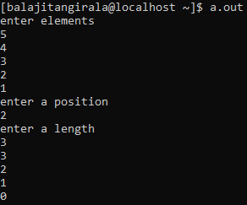

Program : 6  Passing the names to a function that will sort it in ascending order.

Ans :

#include <stdio.h>

#include <stdlib.h>

#include <string.h>

void sort(char** names, int n)

{

int i, j;

for (i = 0; i < n - 1; i++)

for (j = 0; j < n - i - 1; j++)

if (strcmp(names[j], names[j + 1]) > 0)

{

char* temp;

temp = (char*)calloc(30, sizeof(char));

strcpy(temp, names[j]);

strcpy(names[j], names[j + 1]);

strcpy(names[j + 1], temp);

}

}

int main()

{

char** names;

int n, i;

printf("Enter the number of names to be printed: ");

scanf("%d\n", &n);

names = (char**)calloc(n, sizeof(char*));

for (i = 0; i < n; i++)

{

names[i] = (char*)calloc(30, sizeof(char));

scanf("%s", names[i]);

}

sort(names, n);

printf("\nArray after sorting:\n");

for (i = 0; i < n; i++)

printf("%s\n",names[i]);

}

Output :

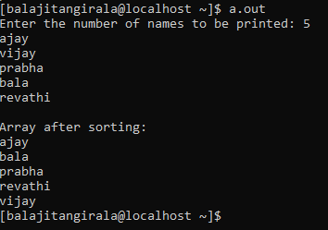

Program : 7(a) Read a string and print reverse of the string.

Ans :

#include<stdio.h>

int main()

{

char str[20],*p;

printf("enter name:");

scanf("%s",str);

for(p=str;*p!='\0';p++);

p--;

for( ;p>=str;p--)

{

printf("%c",*p);

}

}

Output :



Program : 7(b) Read a string and print the string in upper case

Ans :

#include <stdio.h>

int main()

{

char str[20];

char * s = str;

printf("Enter your text : ");

gets(str);

while(*s)

{

*s = (*s >= 'a' && *s <= 'z') ? *s-32 : *s;

s++;

}

printf("Uppercase string : %s\n",str);

return 0;

}

Output :

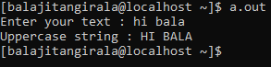

Program : 7 (c)  Read a string and print the number of consonants in the string.

Ans :

#include<stdio.h>

int main()

{

char str[30],*p;

int vcount=0,ccount=0;

printf("enter text:");

gets(str);

p=str;

while(*p!='\0')

{

if(*p=='a' ||*p=='e' ||*p=='i' ||*p=='o' ||*p=='u' ||*p=='A'||*p=='E' ||*p=='I' ||*p=='O' ||*p=='U')

vcount++;

else

ccount++;

p++;

}

printf("consonants=%d",ccount);

return 0;

}

Output :



Program : 7(d) Read your name and print first character of first name, middle name and last name in upper case

Ans :

Output :

Program :8 (a) Encoding

Ans :

#include<stdio.h>

encode(char a[20])

{

int i;

printf("encoding is:");

for(i=0;a[i]!='\0';i++)

{

if(((a[i]>='a')&&(a[i]<='z'))||(a[i]>='A'&&a[i]<='Z'))

printf("%d\n",a[i]);

else if(a[i]>='0'&&a[i]<='9')

{

switch(a[i])

{

case '1':printf("i\n");break;

case '2':printf("ii\n");break;

case '3':printf("iii\n");break;

case '4':printf("iv\n");break;

case '5':printf("v\n");break;

case '6':printf("vi\n");break;

case '7':printf("vii\n");break;

case '8':printf("viii\n");break;

case '9':printf("ix\n");break;

}

}

}

}

main()

{

char str[20];

printf("enter a string");

scanf("%s",&str);

encode(str);

}

Output :

